NAME: Siaruli Prescious Sedzani
St10453924

DESIGN DOCUMENT: PERSONAL BUDGETING APPLICATION

1. Introduction
This document presents the design of a personal budgeting application called BudgetBuddy. The design is informed by an analysis of existing financial applications such as Goodbudget, EveryDollar, and Spendee. These applications were evaluated to identify effective features and areas for improvement.
Personal financial management has become increasingly important due to rising living costs and economic pressures. Many individuals lack the tools or knowledge to manage their money effectively. Budgeting applications provide a practical solution by allowing users to monitor their income, track expenses, and plan for future financial goals.
The aim of this document is to outline a system that is simple, efficient, and accessible to a wide range of users. The proposed design combines useful features from existing applications while addressing their limitations.

2. Application Overview
App Name: BudgetBuddy
Purpose
BudgetBuddy The application enables users to track their income and expenses, set financial goals, and monitor their spending behaviour over time.
The system is designed to present financial data in a clear and user-friendly format. This allows users to quickly understand their financial position and make informed decisions. In addition, the application encourages responsible financial habits by helping users stay within their budget limits.
Target Users
The application is designed for:
- Students managing limited budgets
- Young professionals entering the workforce
- Individuals seeking a simple financial management tool
The system is especially suitable for beginners who require an easy-to-use platform.

3. Key Features
BudgetBuddy incorporates several features to enhance usability and effectiveness.
The application includes expense tracking, allowing users to record all financial transactions. This can be done manually or through automated methods where supported. This ensures accurate monitoring of spending.
Another important feature is budget categorisation, where users can divide their finances into categories such as food, transport, rent, and entertainment. This helps users allocate funds appropriately and identify areas of overspending.
The system also provides notifications and alerts. These alerts inform users when they are approaching or exceeding their budget limits, helping them avoid unnecessary expenses.
Additionally, the application offers reports and analytics, which display financial data using charts and graphs. These visual tools help users understand their spending patterns over time.
A unique feature is the inclusion of shared budgeting, allowing multiple users to manage finances together, which is useful for families or shared households.

4. Inputs and Outputs
Inputs
The system requires users to input the following information:
- Income details
- Expense information (amount, category, and date)
- Budget limits for each category
These inputs form the basis of the system’s calculations.
Outputs
The application generates the following outputs:
- Total available balance
- Spending summaries by category
- Budget progress indicators
- Notifications and alerts
- Visual reports (graphs and charts)
These outputs provide users with clear insights into their financial status.

5. Application Screens (User Interface Design)
The application consists of several key screens designed to ensure ease of use and accessibility.

Dashboard Screen:

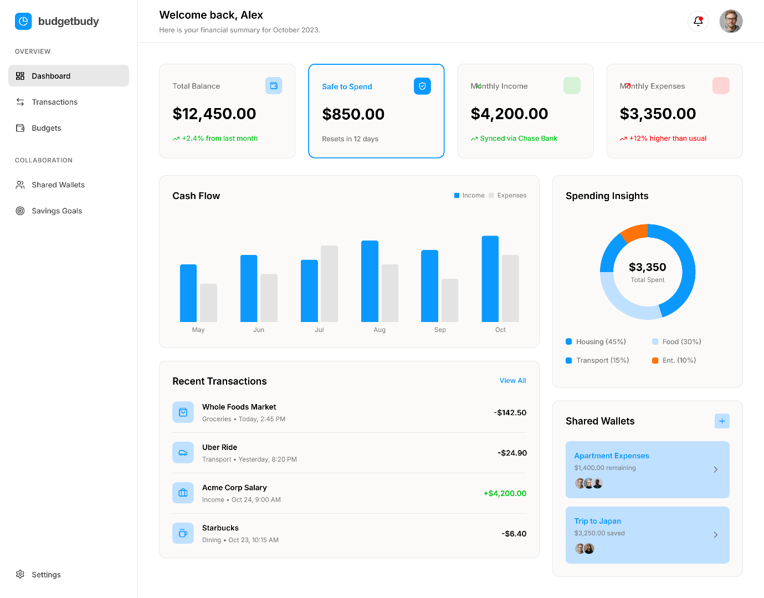

The dashboard serves as the main interface, providing an overview of the user’s financial situation. It displays the total balance, recent transactions, and a graphical representation of spending.

Budget Screen:
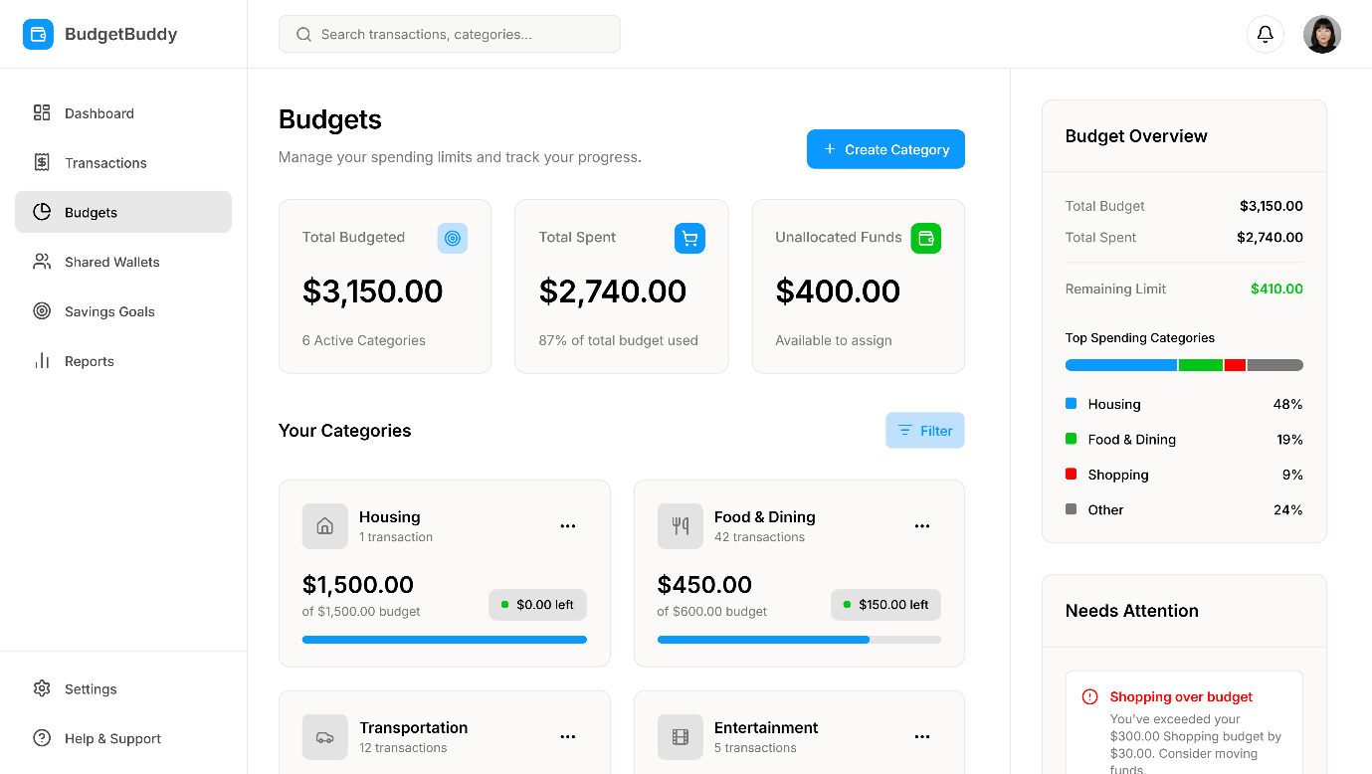

This screen allows users to create and manage budget categories. It shows allocated amounts and tracks spending progress.

Transactions Screen
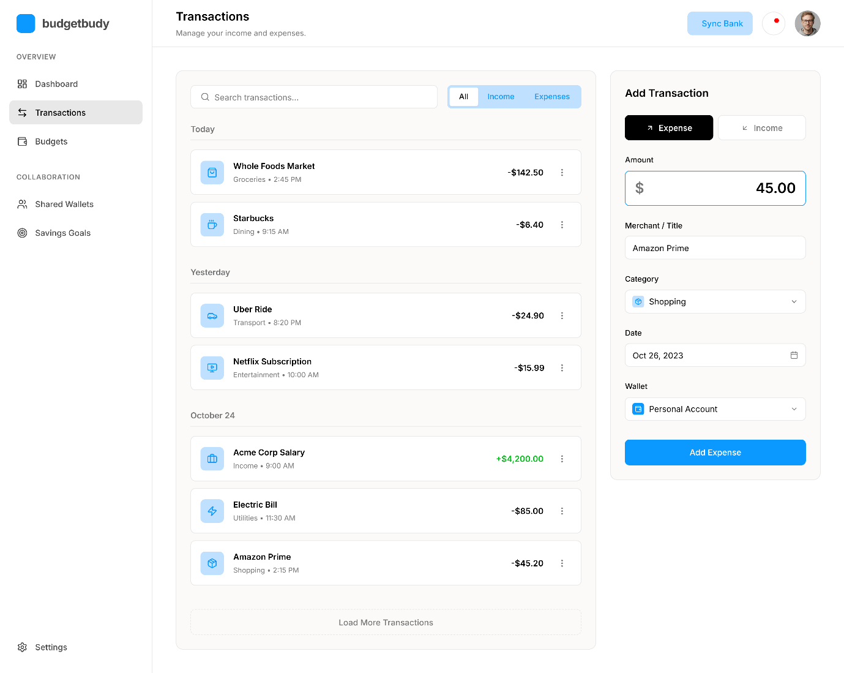

This screen displays all recorded transactions and allows users to add new expenses.

📱 Reports Screen

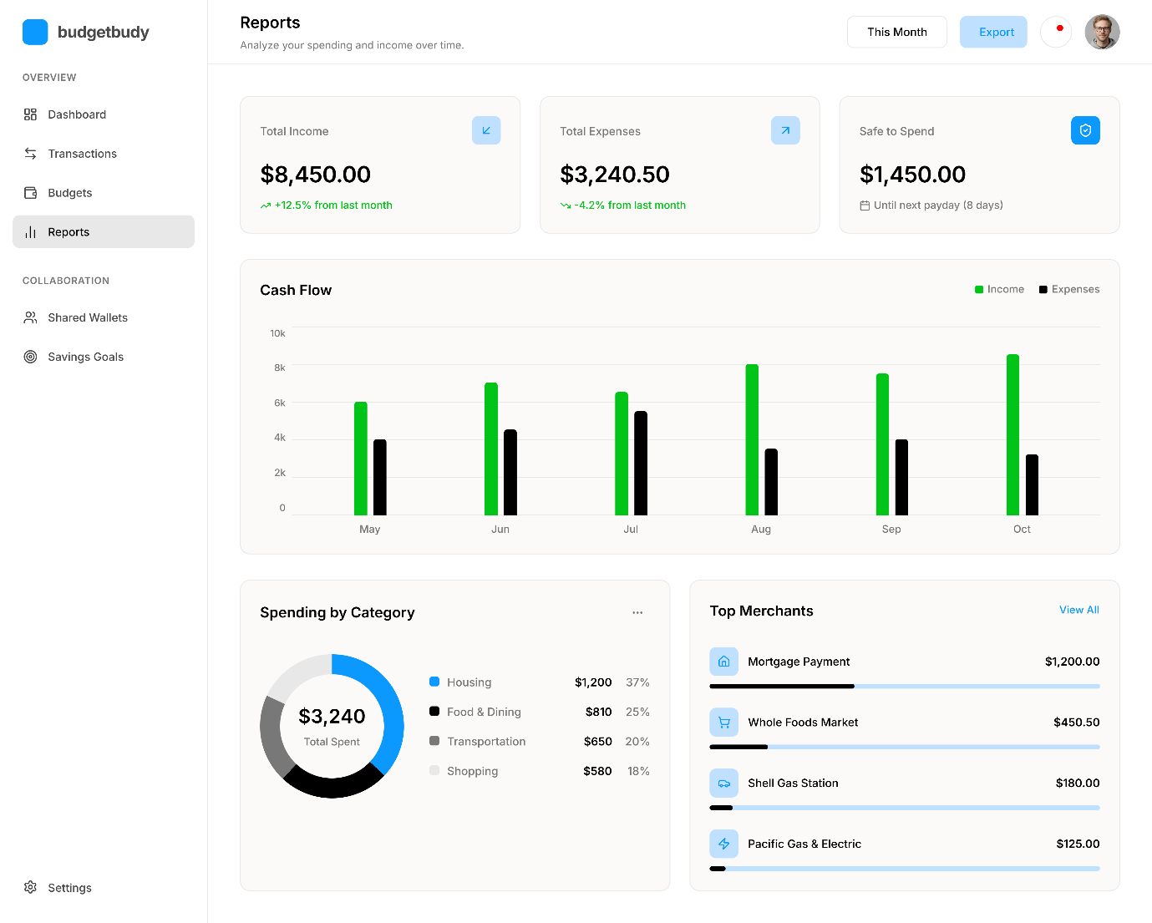

The reports screen provides visual summaries of financial data, helping users analyse their spending behaviour.

6. Navigation Structure
The application uses a bottom navigation bar to allow users to move easily between different sections. The main navigation options include:
- Home (Dashboard)
- Budget
- Transactions
- Reports
This structure ensures that users can access key features quickly and efficiently.

7. System Algorithm
The application follows a logical process to manage financial data:
- The user enters income information
- The user sets budget categories and limits
- The user records expenses
- The system updates the available balance
- The system compares spending against budget limits
- Notifications are generated if limits are exceeded
- Reports and charts are updated automatically
This ensures real-time tracking and accurate financial insights.

8. Database Design
The application uses a structured database to store user data efficiently.
- Users Table: Stores user details such as name and login credentials
- Transactions Table: Stores all expense records
- Budgets Table: Stores category limits and spending data
This design ensures efficient data storage and retrieval.

9. Evaluation of the Design
The proposed system has several advantages. It is user-friendly, making it accessible to beginners, and includes essential financial management tools such as budgeting, expense tracking, and reporting.
However, some limitations exist. The system relies on user input, which may affect accuracy if data is not entered consistently. Additionally, excessive notifications may become distracting if not properly managed.
Despite these limitations, the application provides a practical and effective solution for personal financial management.

10. Conclusion
The BudgetBuddy application offers a comprehensive solution for managing personal finances. By combining essential features such as budgeting, expense tracking, and data visualisation, the system helps users gain better control over their financial activities.
The design prioritises simplicity and usability while still offering enough functionality to support more advanced users. Future improvements may include integration with banking systems, cloud storage, and advanced analytics to further enhance the user experience.
Overall, the application is designed to promote responsible financial behaviour and improve users’ financial well-being.

11. References (Harvard Style)
- Goodbudget. (2026) Goodbudget Budget Tracker. Available at: https://goodbudget.com (Accessed: 23 March 2026).
- EveryDollar. (2026) EveryDollar Budgeting App. Available at: https://www.everydollar.com (Accessed: 23 March 2026).
- Spendee. (2026) Spendee Personal Finance App. Available at: https://www.spendee.com (Accessed: 23 March 2026).
- Apple Inc. (2026) Mobile applications for budgeting. Available at: https://apps.apple.com (Accessed: 23 March 2026).

